Plant Biotechnology 2013 Summer Workshop
Activity: Pipetting July 9, 2013
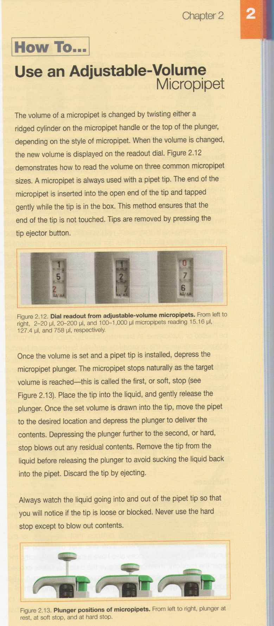
Overview: Scientists routinely measure various volumes of solutions. The equipment used depends on the volume being measured and the accuracy required. For example, a 100-1000 μl adjustable-volume micropipet can measure between 100 and 1000 μl of solutions accurately. However, if you try to use the same pipet to measure less than 100 μl or more than 1000 μl, you may break the pipet or you will measure an inaccurate amount for your experiment. In these activities, you will be measuring and transferring various volumes of liquid with the proper types of micropipette.
Pipetting Protocol:

Activity-
Part 1: Using a 1-10 or 2-20 μl Micropipet

- Set a 1-10 or 2-20 μl Micropipet to deliver 2 μl and insert a clean pipet tip on to the end of the pipet.
- Press down on the pipet plunger until it stops at the first stop.
- Lower the tip into the water and slowly release the plunger to draw 2 μl of water into the tip.
- Put a piece of weighing waxed paper or Parafilm on the table.
- Deliver the 2 μl droplet by pressing down on the plunger until it stops at the first stop.
- Press the plunger to the second stop to blow out the remaining contents.
- Continue adding four more 2 μl droplets side by side to the waxed paper or Parafilm. Is each droplet the same size? If not, wipe off and repeat. When each droplet is the same size, show your Instructor.
- Now put 4, 6, 8, 10 μl droplets next to each other. When comparing the various droplets, do they gradually increase in size?
Part 1-1:
- Now put a piece of weighing waxed paper or Parafilm on a Precision Balance and press TARE
- Set 10 μl on a micropipet
- Draw 10 μl of water and deliver the water on to the wax paper. Record the reading in your notebook.
- Add 5 more 10 μl droplets sequentially while recording the weight reading in your notebook after each 10 μl droplet addition. Does the weight reading increase by 10 mg after each 10 μl droplet addition?
Part 2: Using 20-200 and 100-1000 μl Micropipet
- Label 3 microcentrifuge tubes p200, p1000, and TP and weigh the empty tubes. Record the weight of each of the microcentrifuge tubes.
- Weigh each microcentrifuge tube and record the mass in your laboratory notebook.
- Set a 20-200 μl micropipet to 200 μl. Insert a clean pipet tip on to the end of the micropipet.
- Draw in 200 μl of water and transfer the liquid to the tube labeled p200. Add another 200 μl of water to the same tube.
- Set the micropipet to deliver 100 μl of water and transfer μl of water to the same tube (p200 labeled). Now the p200 tube should contain 500 μl of water
- Set a 100-1000 μl micropipet to deliver 500 μl. Insert a clean pipet tip on to the end of the pipet. Transfer 500 μl of water to the microcentrifuge tube labeled p1000.
- Press the bulb of a 1 ml graduated Transfer Pipet (TP) and draw water up to the 0.5 ml mark. Deliver the water to the microcentrifuge labeled as TP.
- Visually compare the volume of each of the three microcentrifuge tubes. Do they show same level of volumes? Record your observation in your notebook
- Weigh all three microcentrifuge tubes separately and record their mass in your notebook.
- Calculate the mass of the liquid in each microcentrifuge by subtracting the mass of the empty tube. If you have done your pipetting correctly, all three should show 0.5 g of mass in each tube. Record the result and show to the Instructor/TA.

