**Exercise I: Bacterial Transformation with pGLO- Plasmid- Visual Evidence**

In this lab you will perform a procedure known as genetic transformation. Remember that a gene is a piece of DNA which provides the instructions for making (codes for) a protein. This protein gives an organism a particular trait. Genetic transformation literally means “change caused by genes,” and involves the insertion of a gene into an organism in order to change the organism’s trait. Genetic transformation is used in many areas of biotechnology. In agriculture, genes coding for traits such as frost, pest, or spoilage resistance can be genetically transformed into plants. In bioremediation, bacteria can be genetically transformed with genes enabling them to digest oil spills. In medicine, diseases caused by defective genes are beginning to be treated by gene therapy; that is, by genetically transforming a sick person’s cells with healthy copies of the defective gene that causes the disease. You will use a procedure to transform bacteria with a gene that codes for Green Fluorescent Protein (GFP). The real-life source of this gene is the bioluminescent jellyfish *Aequorea* *victoria*. Green Fluorescent Protein causes the jellyfish to fluoresce and glow in the dark. Following the transformation procedure, the bacteria express their newly acquired jellyfish gene and produce the fluorescent protein, which causes them to glow a brilliant green color under ultraviolet light.

Plasmid is routinely used to perform genetic transformation as it can be easily engineered to insert a gene within the plasmid, and thereby inserting the plasmid construct into a host bacterium to express the inserted gene without hindering the viability of host bacteria. This is why the plasmid is called a vector. **Plasmid** is a [DNA](http://en.wikipedia.org/wiki/DNA) molecule that is separate from, and can replicate independently of, the [chromosomal DNA](http://en.wikipedia.org/wiki/GDNA).[[1]](http://en.wikipedia.org/wiki/Plasmid#cite_note-Lipps-0) They are double-stranded and, in many cases, circular. Plasmids usually occur naturally in [bacteria](http://en.wikipedia.org/wiki/Bacterium), but are sometimes found in [eukaryotic organisms](http://en.wikipedia.org/wiki/Eukaryote). However, the plasmid DNA is not easily taken up by the bacteria. To push in the plasmid into the bacteria, the bacteria need to be made competent. Artificial competence is induced by laboratory procedures and involves making the cell passively permeable to DNA by exposing it to conditions that do not normally occur in nature. [Calcium chloride transformation](http://en.wikipedia.org/wiki/Calcium_chloride_transformation) is a method of promoting competence. Chilling cells in the presence of [divalent](http://en.wikipedia.org/wiki/Divalent) [cations](http://en.wikipedia.org/wiki/Cation) such as Ca2+ (in [CaCl2](http://en.wikipedia.org/wiki/Calcium_chloride)) prepares the cell membrane to become permeable to [plasmid DNA](http://en.wikipedia.org/wiki/Plasmid). The cells are incubated on ice with the DNA and then briefly heat shocked (e.g., 42°C for 30–120 seconds) thus allowing the DNA to enter the cells. This method works very well for circular plasmid DNA. An excellent preparation of competent cells will give ~108 colonies per microgram of plasmid.

In this case, the pGLO plasmid has been genetically engineered to carry bla, araC and GFP genes, pBAD promoter and the origin of replication site. The genes which code for arabinose catabolism, *araB, A* and *D*, have been replaced by the single gene which codes for GFP. Therefore, in the presence of arabinose, *araC* protein promotes the binding of RNA polymerase to the pBAD promoter and GFP is produced. Cells fluoresce brilliant green as they produce more and more GFP. In the absence of arabinose, *araC* no longer facilitates the binding of RNA polymerase and the GFP gene is not transcribed. When GFP is not made, bacteria colonies will appear to have a wild-type (natural) phenotype—of white colonies with no fluorescence. The beta lactamase enzyme from bla provides a selection system where only transformed cells with pGlO can grow in ampicillin selection plate while untransformed cells that have not taken up the pGLO plasmid cannot grow on the ampicillin selection plates. The pGLO plasmid provides not only the selection of transformed cells but also gives a phenotypic traits by which we can understand how the arabinose catabolism gene is regulated by the arabinose.

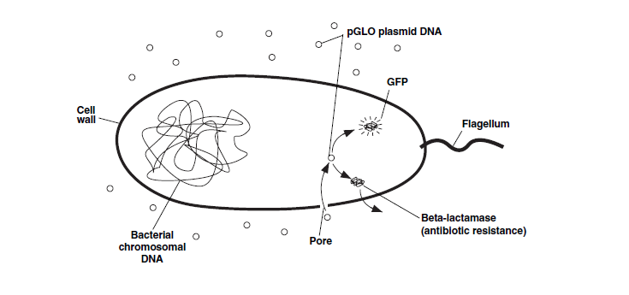

This transformation procedure involves three main steps. These steps are intended to

introduce the plasmid DNA into the E. coli cells and provide an environment for the cells to

express their newly acquired genes.

To move the pGLO plasmid DNA through the cell membrane you will:

1. Use a transformation solution containing CaCl2 (calcium chloride).

2. Heat shock.

For transformed cells to grow in the presence of ampicillin you must:

3. Provide them with nutrients and a short incubation period to begin expressing their

newly acquired genes.

**Procedure:**

1. Label one closed micro test tube +pGLO and another -pGLO. Label both tubes with

your group’s name. Place them in the tube rack



2. Open the tubes and, using a sterile transfer pipet, transfer 250 µl of transformation

solution (CaCl2) into each tube

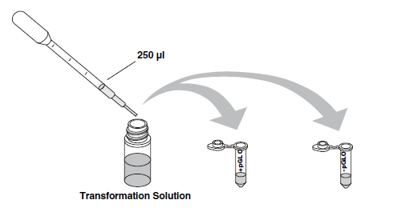

3. Place the tubes on ice.

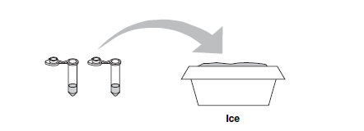

4. Use a sterile loop to pick up 2–4 large colonies of bacteria from supplied bacterial colony containing plate. Pick up the +pGLO tube and immerse the loop into the transformation solution at the bottom of the tube. Spin the loop between your index finger and thumb until the entire colony is dispersed in the transformation solution (with no floating chunks). Place the tube back in the tube rack in the ice. Using a new sterile loop, repeat for the -pGLO tube. [Select starter colonies that are "fat" (ie: 1–2 mm in diameter). It is important to take individual colonies (not a swab of bacteria from the dense portion of the plate), since the bacteria must be actively growing to achieve high transforation efficiency. Choose onlybacterial colonies that are uniformly circular with smooth edges].

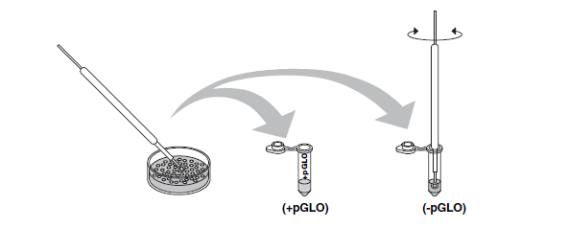

5. Examine the pGLO DNA solution with the UV lamp. Note your observations. Immerse a new sterile loop into the pGLO plasmid DNA stock tube. Withdraw a loopful. There should be a film of plasmid solution across the ring. This is similar to seeing a soapy film across a ring for blowing soap bubbles. Mix the loopful into the cell suspension of the +pGLO tube. **Do not add plasmid DNA to the -pGLO tube**. Close both the +pGLO and -pGLO tubes and return them to the rack on ice

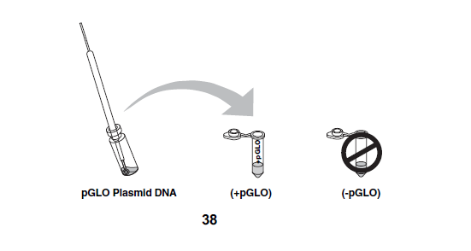

6. Incubate the tubes on ice for 10 min. Make sure to push the tubes all the way down in the rack so the bottom of the tubes stick out and make contact with the ice.

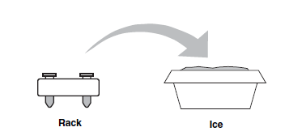

7. While the tubes are sitting on ice, label your four LB nutrient agar plates on the bottom

(**not the lid**) as follows:

• Label one LB/amp plate: + pGLO

• Label the LB/amp/ara plate: + pGLO

• Label the other LB/amp plate: - pGLO

• Label the LB plate: - pGLO

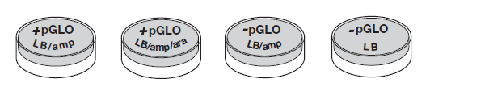

8. Heat shock. Using the foam rack as a holder, transfer both the (+) pGLO and (-) pGLO tubes into the water bath, set at 42oC, **for exactly 50 sec.** Make sure to push the tubes all the way down in the rack so the bottom of the tubes stick out and make contact with the warm water. Double-check the temperature of the water bath with two thermometers to ensure accuracy. When the 50 sec are done, place both tubes back on ice. **For the best transformation results, the transfer from the ice (0°C) to 42°C and then back to the ice must be rapid**. Incubate tubes on ice for 2 min.

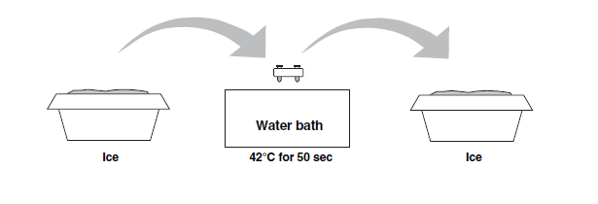

9. Remove the rack containing the tubes from the ice and place on the bench top.

Open a tube and, using a new sterile pipet, add 250 µl of LB nutrient broth to the

tube and reclose it. Repeat with a **new sterile pipet** for the other tube. Incubate the

tubes for 10 min at room temperature.

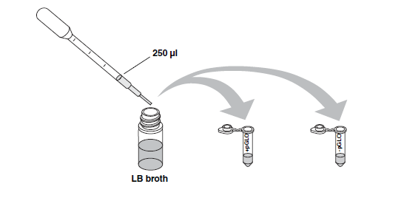

10. Gently flick the closed tubes with your finger to mix and resuspend the bacteria. Using **a new sterile pipet** **for each tube**, pipet 100 µl of the transformation and control suspensions onto the appropriate nutrient agar plates

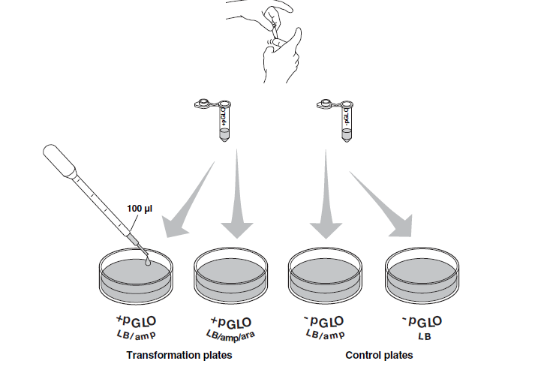

11. Use a new sterile loop for each plate. Spread the suspensions evenly around the surface of the LB nutrient agar by quickly skating the flat surface of a **new sterile loop** back and forth across the plate surface. **DO NOT PRESS TOO DEEP INTO THE AGAR.** Uncover one plate at a time and re-cover immediately after spreading the suspension of cells. This will minimize contamination.

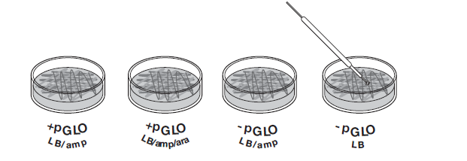

12. Stack up your plates and tape them together. Put your group name and class period on the bottom of the stack and place the stack of plates upside down in the 37°C incubator until the next day. The plates are inverted to prevent condensation on the lid which may drip onto the culture and interfere with your results.

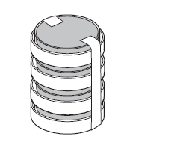

**Data Collection and Analysis**

**A. Data Collection**

Observe the results you obtained from the transformation lab under normal room lighting.

Then turn out the lights and hold the ultraviolet light over the plates. Alternatively the protocol can incorporate digital documentation of the plates with Vernier’s Blue Digital BioImaging System (Appendix E).

1. Carefully observe and draw what you see on each of the four plates. Put your drawings

in the data table below. Record your data to allow you to compare observations of the

“+ pGLO” cells with your observations for the non-transformed E. coli. Write down the

following observations for each plate.

2. How much bacterial growth do you see on each plate, relatively speaking?

3. What color are the bacteria?

4. How many bacterial colonies are on each plate (count the spots you see).

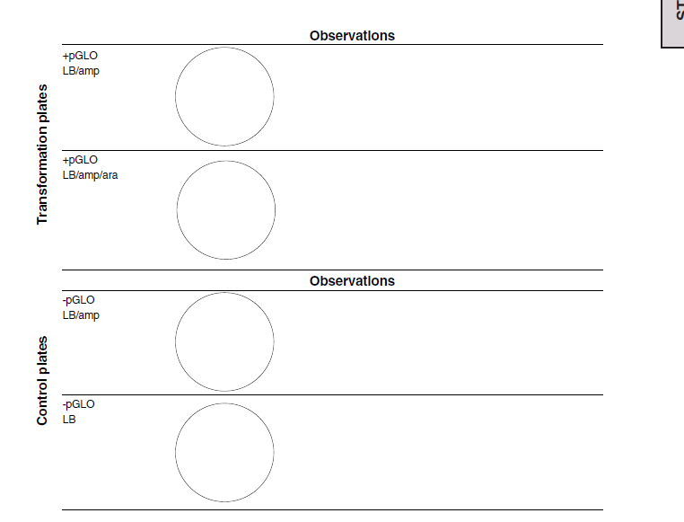

**B. Analysis of Results**

The goal of data analysis for this investigation is to determine if genetic transformation

has occurred.

1. Which of the traits that you originally observed for E. coli did not seem to become

altered? In the space below list these untransformed traits and how you arrived at this

analysis for each trait listed.

Original trait Analysis of observations

2. Of the E. coli traits you originally noted, which seem now to be significantly different

after performing the transformation procedure? List those traits below and describe the

changes that you observed.

New trait Observed change

3. If the genetically transformed cells have acquired the ability to live in the presence of the antibiotic ampicillin, then what might be inferred about the other genes on the lasmid that you used in your transformation procedure?

4. From the results that you obtained, how could you prove that the changes that occurred

were due to the procedure that you performed?