β-Glucuronidase (GUS) Reporter Gene to study Environmental stress induced RACK1 gene expression

Reporter genes are commonly used in prokaryotes and eukaryotes to measure promoter activity of a gene of interest. Transgenic organisms have to be generated by transformation with a chimeric gene consisting of the respective promoter fused with a reporter gene. This allows study of gene expression pattern from the gene under study. In this regard, transgenic plants were developed with gene construct that include the promoter region (1000 bp upstream from the Gene transcription start site) of RACK1 gene fused with a bacterial reporter gene uidA that encodes the GUS enzyme. The GUS activity can be assayed qualitatively by staining with the chromogenic substrate X-Gluc (5-bromo-4-chloro-3-indolyl β-D-glucuronide). The GUS enzyme hydrolyzes X-Gluc to a water-soluble indoxyl intermediate that is further dimerized into a dichloro-dibromo-indigo blue precipitate by an oxidation reaction. In optimal reaction conditions, the water-insoluble indigo blue is located at the place of enzyme activity. The X-Gluc-based assays are usually done on intact seedlings, explants, or sliced tissues. Development of blue color within tissues reflects the respective gene promoter activity and the GUS activity is used as a surrogate for the respective gene expression within the observed tissue/cellular location. For example, if we observe that in response to a particular extrinsic environmental signal the promoterRACK1A:GUS fusion gene is expressed in only the meristematic tissues of a seedlings (as evident by the development of blue color), we can safely assume that RACK1A gene may have some regulatory roles within the meristematic tissues of the plant.

In this lab, we are going to use two different Arabidopsis plant lines that have been transformed with the promoter regions of RACK1A gene fused with the E. coli uidA gene sequence. The seeds from the two lines were grown for one week on MS culture media. RACK1A gene is known to regulate diverse environmental stress signaling pathways including salt and sugar signaling pathways. In this lab we are going assay whether excess salt stress signaling pathways have any role in inducing/repressing RACK1 gene expressions. The results will be instrumental to discern, if any, the role of RACK1 genes in the salt signaling pathways.

Protocol:

- Collect seedlings from the culture plates
- Put 3 ml of MS-media (Arabidopsis growth culture) in one of the wells of a 12 well culture plate.
- In another well, put 3 ml of MS media with 250 mM NaCl.
- Put at least three seedlings from one of the selected plant lines to each of the wells
- Incubate at room temperature for three hours
- Prepare fresh staining solution by adding 2 mg/ml X-Gluc to 1X staining buffer.
Staining buffer: 100 mM Tris-HCl, pH 7.5, 50 mM NaCl, 2 mM potassium ferricyanide. (ferri or ferrocyanide oxidize the soluble X-Gluc product, thus precipitating it in place, but they also interfere with GUS enzyme activity- balance should be found). A drop of Silwett should be added to facilitate absorption of the X-Gluc through the waxy surface of the seedlings.
7. Incubate the seedlings in the staining buffer (3 ml/well in a 12 well plate)
8. Infiltrate the seedlings under vacuum for 15 minutes. Release the vacuum slowly.
If the seedlings do not sink, repeat vacuum treatment.
- Incubate typically overnight at 37⁰C in the dark.
- Next morning remove the staining buffer and incubate the seedlings in 70% ethanol to clear the chlorophylls.
- At this point, the tissues can be stored at 4⁰C for extended period.
- Otherwise, observe the tissues under the dissecting microscope (this is best done once the tissue is completely cleared of all chlorophylls)

A typical seedling root showing GUS stained lateral root primordial.

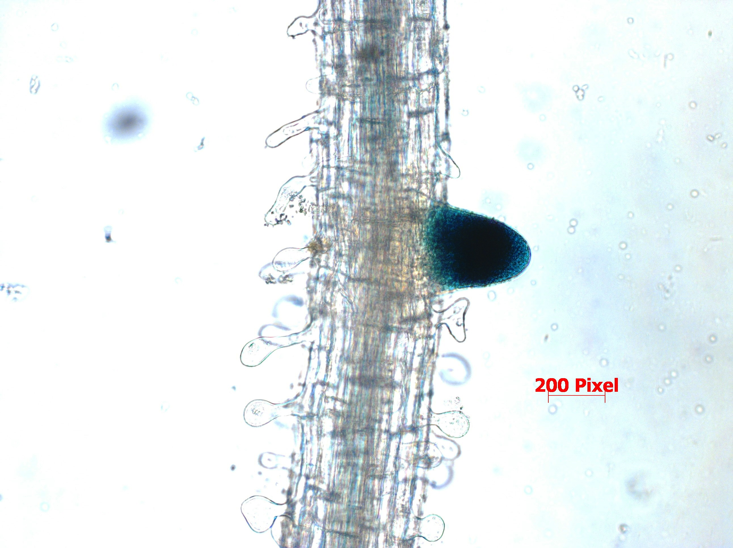

Issues to consider:
- Carefully observed the GUS stained tissues in each of the six lines.
- Do both of the lines from the gene show similar staining pattern. Why is it important to have similar staining pattern?
- Do you see any pattern of GUS expression in response to a particular stress under study?
- Considering the expression pattern from all lines, what can you generally conclude about stress induced RACK1 gene expression pattern?

